SUSTAINABLE OUTREACH AND UNIVERSAL LEADERSHIP LIMITED
(SOUL)



HUMAN RESOURCE MANAGEMENT

REQUIREMENT DOCUMENT

1.Master Data / Screens
  - Employment Type:

- Employment Type is to employ people under a number of categories each having their own wage and leave entitlements such as:

- Intern
- Full-time
- Part-time
- Probation and so on

- Employment Type shall have one input field:

Label | Field Type | Mandatory | Linked to
Employment Type | Data | Y | -

- Employment Type UI shall look like:

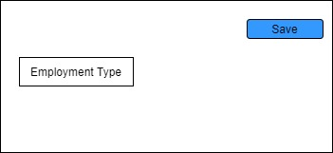

1.2 Branch:

- Branch consist list of different locations of a company.This form shall have one input field :
Label | Field Type | Mandatory | Linked to
Branch | Data | Y | -

- Branch UI shall look like:

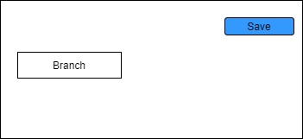

1.3 Department:

- Department is a specialized functional division in an organization like:

- School of Engineering Department
- School of Services Department
- Department screen shall consist of following fields:

Label | Field Type | Mandatory | Linked to
Department | Data | Y | -
Parent Department | Link |  | Department
Company | Link | Y | Company
Is Group | Checkbox
Is Stream | Checkbox
Disabled | Checkbox
Leave Block List | Link |  | Leave Block List
Leave Approvers | Table |  | Leave Approver
Expense Approvers | Table |  | Expense Approvers
Shift Request Approvers | Table |  | Shift Request Approvers

- Department UI shall look like

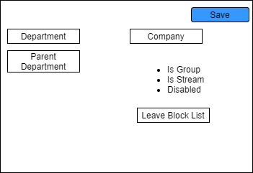

1.4 Designation

- Designations are official job titles given to employees like:
- Software Engineer
- Project Manager
- Designation screen shall consist of following fields:

Label | Field Type | Mandatory | Linked to
Designation | Data | Y | -
Description | Long Text
Required Skills | Table |  | Skills(List of different skills)

- Designation UI shall look like:

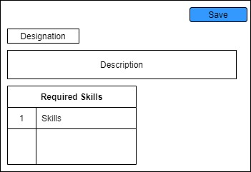

1.5 Holiday List:

- Holiday screen consist of list of different holidays that can be assigned to the employees based on the requirement.

- Holiday List shall consists of following fields :
Label | Field Type | Mandatory | Linked to | Options
Holiday List Name | Data | Y | -
From Date | Date | Y
To Date | Date | Y
Weekly Off | Select |  |  | Sunday/Saturday
Add to Holidays | Button
Holiday List | Table |  | Holiday List(fields:Date,Description)

- Holiday List UI shall look like:

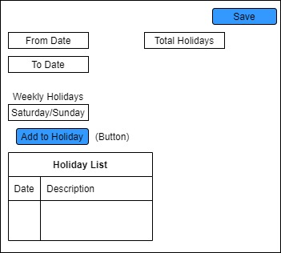

1.6 Shift Type:

- Shift Type manages the shift of the employee like Day Shift and Night Shift.
- Shift Type shall consists of following fields :

Label | Field Type | Mandatory | Linked to
Name | Data | Y | -
Start Time | DateTime | Y
End Time | DateTime | Y
Holiday List | Link |  | Holiday List

- Shift Type UI shall look like :

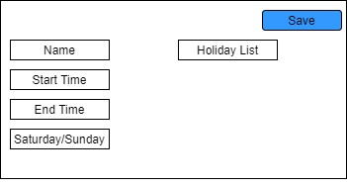

1.7 Employee:

- Employee screen shall captures the demographic details,personal details,professional details and so on of an individual who is a part of the organization.

- Employee Screen shall have the following fields :
Label | Field Type | Mandatory | Linked to | Options
Series | Select | Y | - | Default
First Name | Data | Y
Middle Name | Data
Last Name | Data | Y
Gender | Link | Y | Gender
Date of Birth | Date
Date of Joining | Date
Employee Number | Data
Emergency Contact
Emergency Contact Name | Data
Emergency Phone | Data
Relation | Data
Joining Details
Job Applicant Id | Link |  | Job Applicant
Offer Date | Date
Confirmation Date | Date
Date of Retirement | Date
Department and Grades
Department | Link |  | Department
Designation | Link |  | Designation
Branch | Link |  | Branch
Reports to | Link |  | Employee
Approver
Expense Approver | Link |  | User
Leave Approver | Link |  | User
Shift Approver | Link |  | User
Attendance/Leave Details
Attendance Device | Data
Holiday List | Link |  | Holiday List
Default Shift | Link |  | Shift Type
Salary Details
Salary Mode | Select |  |  | Bank/Cash/Cheque
Payroll Cost Center | Link |  | Cost Center
PAN Number | Data
Provident Fund Account | Data
Heath Insurance
Heath Insurance Provider | Link |  | Employee Health Insurance
Health Insurance No. | Data
Contact Details
Mobile | Data
Preferred Email | Email
Personal Email | Email
Company Email | Email
Permanent Address | Small Text
Current Address | Small Text
Educational Qualification
Education | Table |  | Employee Education(fields:-School/University,Qualification,Level,Year of Passing
Previous Work Expierence
Employee External Work History | Table |  | Employee External Work History(fields:Company,Designation,Salary,Address)
History in Company
Employee Internal Work History | Table |  | Employee Internal Work History(Branch,Department,  Designation,From Date to Date)

- Company shall be fetched from Company master screen
- Department shall be fetched from Department master screen
- On creation of an employee, user shall also be automatically created

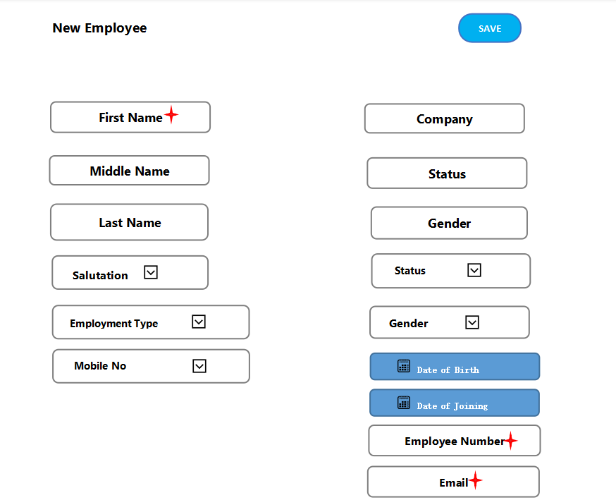

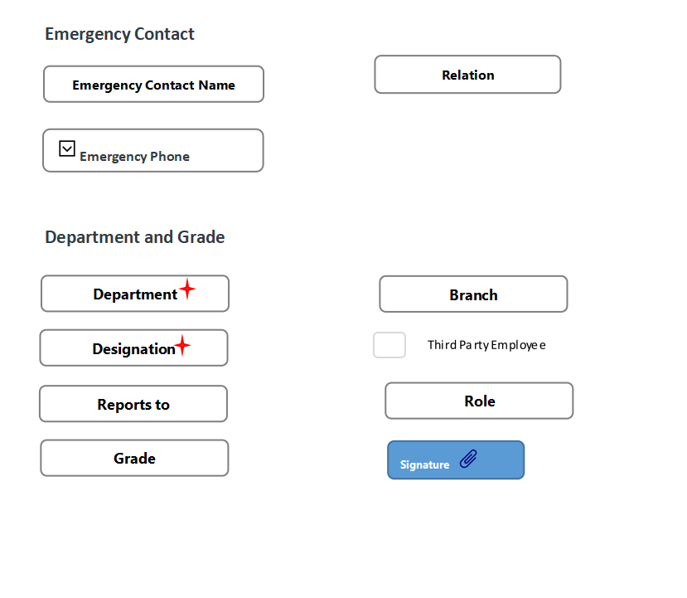

Recruitment
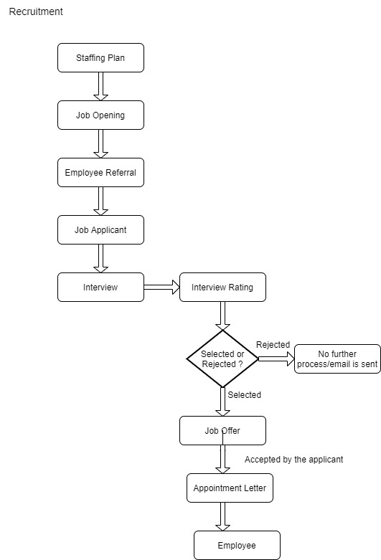
2.1 Staffing Plan:

- Staffing Plan helps you plan manpower requirements of the company .Staffing Plan screen shall consist of following features/fields:

Label | Field Type | Mandatory | Linked to
Name | Data | Y | -
Company | Link | Y | Company
Department | Link |  | Department
From Date
To Date
Staffing Plan Detail | Table | Y | Staffing Plan Detail(with fields:Designation,Vacancies,Estimated Cost Per Position)
Total Estimated Budget | Currency

2.2 Job Opening:

- Job Opening make the record of the open vacancies in the company.
- Number of Job Openings you can create for a Designation is restricted according to the vacancies planned by the Staffing Plan defined for the company.
- Job Opening Screen shall consists of following fields/features:

Label | Field Type | Mandatory | Linked to | Options
Job Title | Data | Y | -
Company | Link | Y | Company
Status | Select |  |  | Open,Closed
Designation | Link |  | Designation
Department | Link |  | Department
Staffing Plan | Link |  | Staffing Plan
Publish on website | Check
Description | Text Editor
Currency | Link |  | Currency
Lower Range | Currency |  |  | Currency
Upper Range | Currency |  |  | Currency

2.3 Job Applicant:

- Job Opening make the record of the people who applies for a job in company against a particular Job Opening .
- This screen shall consist of following fields:

Label | Field Type | Mandatory | Linked to | Options
Details
Applicant Name | Data | Y
Email Address | Data | Y |  | Email
Phone No. | Data |  |  | Phone
Country | Link |  | Country
Job Opening | Link |  | Job Opening
Designation | Link |  | Designation
Status | Select | Y |  | Open,Replied,Rejected,  Hold,Accepted
Source and Rating
Source | Link |  | Job Applicant Source
Source Name | Link |  | Employee
Employee Referral | Link |  | Employee Referral
Applicant Rating | Rating
Resume
Cover Letter | Text
Resume Attachment | Attach
Resume Link | Data
Salary Expectation
Currency | Link |  | Currency
Lower Range | Currency |  |  | currency
Upper Range | Currency |  |  | currency

- If you select the Source as Employee Referral, you will have to select the Employee name in the Source Name Field.

- Job Applicant
- UI shall look like :

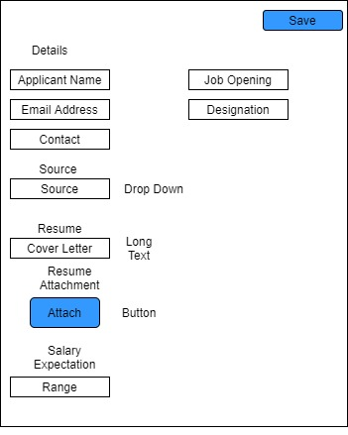

2.4 Employee Referral:

- Employee Referral is a process where existing employees refer a suitable candidate from their network for a vacant designation/position.
- When you submit an employee referral document the initial status will be "Pending". After submitting the document, the "Create Job Applicant" button will appear at the top right corner.
- Clicking this button will create a new Job Applicant with the status "Open". The status of the Employee Referral document will change to "In Process".
- When someone changes the status of the Job Applicant to "Hold" or "Replied", the status of the Employee Referral will remain "In Process". If the status of the Job Applicant changes to "Accepted" or "Rejected", the status of the Employee Referral document will also change to "Accepted" or "Rejected" respectively.
- This screen shall consist of following fields:

Label | Field Type | Mandatory | Linked to | Options
First Name | Data | Y | -
Last Name | Data | Y
Email | Data | Y |  | Email
Contact No. | Data |  |  | Phone
Resume | Attach
Resume Link | Data
Date | Date | Y
Status | Select | Y |  | Pending,In Process,Accepted,Rejected
For Designation | Link | Y | Designation
Current Employer | Data
Referrer Details
Referrer | Link | Y | Employee
Referrer Name | Data
Additional Information
Why is this Candidate Qualified for this Position? | Text Editor

2.5 Interview Type:

- Interview type consist list of different type of interview like Technical Interview,HR Interview and so on.This screen shall consist of fields like:

Label | Field Type | Mandatory | Linked to
Name | Data | Y | -
Description | Text

2.6 Interview Round:

- Interview type consist list of different type of interview round like Technical round,HR round and so on.This screen shall consist of fields like:

Label | Field Type | Mandatory | Linked to | Options
Round Name | Data | Y | -
Interview Type | Link | Y | Interview Type
Interviewers | Table MultiSelect |  |  | Interviewer
Designation | Link |  | Designation
Expected Average Rating | Rating | Y
Expected Skill set | Table | Y | Expected Skill Set

2.7 Interview :

- Interview consist list of interview scheduled for a particular Job Applicant for different interview round. like Technical .This screen shall consist of fields like:

Label | Field Type | Mandatory | Linked to | Options
Details | Data | Y | -
Interview Round | Link | Y | Interview Round
Job Applicant | Link | Y | Job Applicant
Job Opening | Link |  | Job Opening
Designation | Link |  | Designation
Status | Select |  |  | Pending,Under Review,Cleared,  Rejected
Scheduled On | Date | Y
From Time | Time | Y
To Time | Time | Y
Feedback | Table |  | Interview Detail(fields:Interviewer,Rating,Feedback,Result
Ratings
Expected Average Rating | Rating
Obtained Average Rating | Rating
Interview Summary | Text

2.8 Job Offer :

- Job Offer is given to selected candidates after interview and selection which states the offered salary package, designation, grade, department, number of days entitled for leave among other information .
- This screen shall consist of fields/features like:

Label | Field Type | Mandatory | Linked to | Options | Fetch From
Job Applicant | Link | Y | Job Applicant
Applicant Name | Data | Y |  |  | Job Applicant
Applicant Email Address | Data |  |  |  | Job Applicant
Status | Select |  |  | Awaiting Response,  Accepted,  Rejected
Offer Date | Date | Y
Designation | Link | Y | Designation
Company | Link | Y | Company
Job Offer Terms | Table |  | Job Offer Term
Select Terms and Conditions | Text Editor
Printing Heading | Link |  | Print Heading

2.9 Appointment Letter :

- Appointment Letter is a letter written by the employer requesting the selected candidates to join in a specific position .
- This screen shall consist of fields/features like:

Label | Field Type | Mandatory | Linked to | Options | Fetch From
Job Applicant | Link | Y | Job Applicant
Applicant Name | Data | Y |  |  | Job Applicant
Company | Link | Y | Company
Appointment Date | Date | Y
Appointment Letter Template | Link | Y | Appointment Letter Template
- Appointment Letter Template-It is a pre defined format for letter and can be
linked with Appointment Letter.

Employee Life-cycle
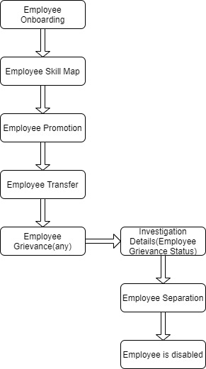
3.1 Employee On boarding :

- In the process of hiring an Employee, there are set of standard activities which need to be executed. This feature helps you to maintain the masters of these activities, and create a set of tasks at the time of each Employee hiring.
- Employee On boarding is created for a Job Application, who is approved for the hiring.
- This screen shall consist of fields/features like:
Label | Field Type | Mandatory | Linked to | Options
Job Applicant | Link | Y | Job Applicant
Job Offer | Link | Y | Job Offer
Employee Name | Data | Y
Employee | Link |  | Employee
Date of Joining | Data
Status | Select |  |  | Pending,In Process,Completed
Employee On -boarding Template | Link |  | Employee On -boarding Template
Company | Link |  | Company
Department | Link |  | Department
Designation | Link |  | Designation
Employee Grade | Link |  | Employee Grade
Project | Link |  | Project
Activities | Table |  | Employee Boarding Activity

- Employee On boarding Template(The Employee On boarding Template is a blueprint which contains a predefined list of Activities for Employee On boarding. An Employee On boarding Template can be created for a particular Department, Designation and Employee Grade.)
- Activities(Tabular Format-Data will be auto-fetched from Employee On -boarding Template)

3.2 Employee Skill Map :

- Employee Skill Map is a record which helps your organization track your Employee's skill sets and training.
- It can be used to rate each skill of the Employee and track their growth after each internal training.
- This screen shall consist of fields/features like:

Label | Field Type | Mandatory | Linked to | Options | Fetch From
Employee | Link | Y | Employee
Employee Name | Read Only |  |  |  | Employee
Designation | Read Only |  |  |  | Employee
Skills
Employee Skills | Table |  | Employee Skill
Training | Table |  | Employee Training

3.3 Employee Promotion :

- Employee Promotion is a process through which an Employee of a company is given a higher share of duties, a higher pay-scale or both.
- This screen shall consist of fields/features like:

Label | Field Type | Mandatory | Linked to | Options | Fetch From
Employee | Link | Y | Employee
Employee Name | Data |  |  |  | Employee
Department | Link |  | Department |  | Employee
Promotion Date | Date
Company | Link |  | Company
Employee Promotion Details
Employee Promotion Detail | Table |  | Employee Promotion Detail(fields:(Employment type/department/  designation/salutation and so on),Current Designation,New Designation)

- Employee Promotion document can be submitted on or after Promotion Date.
- Once submitted all the changes added to Promotion Details table will be applied to the Employee.

3.4 Employee Transfer :

- Employee Transfer is a form of internal mobility, in which the Employee is shifted from one job to another usually at a different location, department, or unit.
- This screen shall consist of fields/features like:

Label | Field Type | Mandatory | Linked to | Options | Fetch From
Employee | Link | Y | Employee
Employee Name | Data | Y |  |  | Employee
Transfer Data | Date | Y | Company
Company | Link | Y | Company
New Company | Link | Y | Company
Department | Link |  | Department
Employee Transfer Details
Employee Transfer Detail | Table | Y | Employee Transfer Details(Tabular Format with fields like Property(Employment type/department/  designation/  salutation and so on),Current Designation,New Designation)
Re-allocate Leaves | Check
Create New Employee Id | Check
New Employee ID | Link |  | Employee

- If Create New Employee ID is checked, a new Employee will be created with property changes in Transfer Details table and old Employee will be marked as relieved
- Transfer document can be submitted on or after Transfer Date
- Once submitted all the changes added to Transfer Details table will applied to Employee.

3.5 Grievance Type :

- Grievance type consist of list of grievance i.e any dissatisfaction or feeling of injustice having connection with one's employment situation which is brought to the attention of management.
- This screen shall consist of fields/features like:

Label | Field Type | Mandatory | Linked to
Name | Data | Y | -
Description | Text

3.6 Employee Grievance :

- Employee Grievance is a formal complaint raised by an employee against a fellow employee or manager, or even against the employer. Employees usually file grievances for workplace harassment, discrimination, nepotism, concerns regarding team management or regarding terms of the employment.
- This screen shall consist of fields/features like:

Label | Field Type | Mandatory | Linked to | Fetch From
Subject | Data | Y | -
Raised By | Link | Y | Employee
Employee Name | Data |  |  | Employee
Designation | Link
Date | Date | Y
Status | Select | Y
Reports To | Link
Grievance Details
Grievance Against Party | Link |  | Doctype
Grievance Against | Dynamic Link | Y | Grievance Against
Grievance Type | Link |  | Grievance Type
Associated Document Type | Link |  | Doctype
Description | Text
Investigation Details
Cause | Text
Resolution Details
Resolved By | Link | User
Resolution Date | Date
Employee Responsible | Link | Employee

3.7 Employee Separation:

- Employee Separation is a situation when the service agreement of an Employee with his/her organization comes to an end and the Employee leaves the organization.
- Employee Separation is created for an Employee who has resigned or terminated from the organization.
- This screen shall consist of fields/features like:

Label | Field Type | Mandatory | Linked to | Options
Employee | Link | Y | Employee
Employee Name | Data | Y
Department | Link | Y | Department
Designation | Link |  | Designation
Employee Grade | Link |  | Employee Grade
Company | Link |  | Company
Status | Select |  |  | Pending  In Process  Completed
Resignation Letter Date | Date
Project | Link |  | Project
Separation Activities | Link
Employee Separation Template | Link |  | Employee Separation Template
Activities | Table |  | Employee Boarding Activity

- Employee Separation Template(Employee Separation Template is a blueprint which contains a predefined list of Activities for Employee Separation. An Employee Separation Template can be created for a particular Department, Designation and Employee Grade.)
- Employee Separation Activities(Tabular format,auto-fetched when employee separation template is selected.)
- If an Employee Separation Template isn't created, you can directly fill the separation information in the Employee Separation screen itself
- The 'Status' of the Employee Separation will change to Completed once all the associated Activities are complete.

4. Shift Management
4.1 Shift Request:

- Shift Request is used by an employee to request for a particular Shift Type like day shift,night shift.
- This screen shall consist of fields/features like:

Label | Field Type | Mandatory | Linked to | Fetch From | Options
Shift Type | Link | Y | -
Employee ID | Link | Y | Employee
Employee Name | Data |  |  | Employee
Department | Link |  | Department
Status | Select |  |  |  | Draft  Approved  Rejected
Company | Link |  | Company
From Date | Date
To Date | Date

- Shift Request Approver can also be set in the employee master.

4.2 Shift Assignment:

- A Shift Assignment is created to assign a particular shift type to an employee for a specific period.
- This screen shall consist of fields/features like:
Label | Field Type | Mandatory | Linked to | Fetch From
Employee | Link | Y | Employee
Employee Name | Data |  |  | employee
Shift Type | Link | Y | Shift Type
Status | Select |  | Active  Inactive
Company | Link | Y | Company
Start Date | Date | Y
End Date | Date
Shift Request | Link |  | Shift Request
Department | Link |  | Department | employee

- The Assignment for active shift-type will be for a fixed period if there is an End Date.Otherwise, it will be treated as an ongoing shift with no End Date.
- Users can update the End Date and status even after submitting the document.

5.Leave Management :
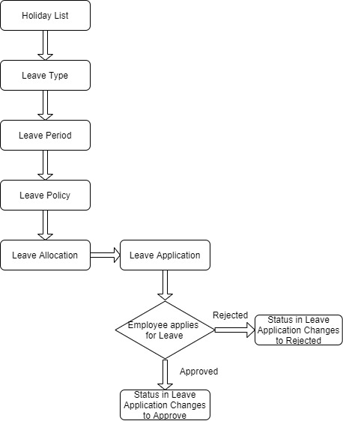
5.1 Leave Type:

- Leave Type refers to the types of leaves allocated to an Employee which they can use while making Leave Applications.
- This screen shall consist of fields/features like:
Label | Field Type | Mandatory | Linked to | Fetch From | Options
Leave Type Name | Data | Y | -
Maximum Leave Allocation Allowed | Int
Applicable After (Working Days) | Int
Maximum Consecutive Leaves Allowed | Int
Is Carry Forward | Check
Is Leave Without Pay | Check
Is Partially Paid Leave | Check
Fraction of Daily Salary per Leave | Float
Is Optional Leave | Check
Allow Negative Balance | Check
Allow Over Allocation | Check
Include holidays within leaves as leaves | Check
Is Compensatory | Check
Carry Forward | Check
Maximum Carry Forwarded Leaves | Float
Expire Carry Forwarded Leaves (Days) | Int
Encashment
Allow Encashment | Check
Encashment Threshold Days | Int
Earning Component | Link |  | Salary Component
Earned Leave
Is Earned Leave | Check
Earned Leave Frequency | Select |  |  |  | Monthly  Quarterly  Half-Yearly  Yearly

- Check-boxes shall be present:

- Max Leaves Allowed:This field allows you to set the maximum number of the annual allocation of this Leave Type while creating the Leave Policy.
- Applicable After(Working Days):Enter the minimum number of working days here. Only the employees who have worked for this number of days or more will be allowed to apply for this particular leave type. Any other leaves (such as Casual Leave, Sick Leave.etc.) availed by the Employees after their joining date will also be considered while calculating working days of the Employee.
- Maximum Continuous Days Applicable: It refers to the maximum number of days this particular Leave Type can be availed at a stretch. If an employee exceeds the maximum number of days, their extended leave will be considered as ‘Leave Without Pay'.
- Is Carry Forward:If checked, the balance leaves of this Leave Type will be carried forward to the next allocation period.
- Is Leave Without Pay:This ensures that the Leave Type will be treated as leaves without pay and salary will get deducted for this Leave Type.
- Allow Negative Balance:If checked, the system will always allow to apply and approve Leave Applications for the Leave Type, even if there is no leave balance.
- Is Compensatory:Compensatory leaves are leaves granted for working overtime or on holidays, normally compensated as an encashable leave.

5.2 Leave Period:

- A Leave Period is a duration of time for which leaves are allocated.Companies manage leaves based on a Leave Period, corresponding to a calendar year or the fiscal year.
- This screen shall consist of fields/features like:

Label | Field Type | Mandatory | Linked to | Fetch From | Options
From Date | Date | Y | -
To Date | Date | Y
Is Active | Check
Company | Link |  | Company
Holiday List for Optional Leave | Link |  | Holiday List

- The 'Holiday List for Optional Leaves' is not the same as the usual 'Holiday List'. This list will contain a list of optional holidays only.

5.3 Leave Policy:

- The amount of entitled leaves in a Company for an Employee in a Leave Period is known as Leave Policy.
- This screen shall consist of fields/features like:

Label | Field Type | Mandatory | Linked to | Fetch From | Options
Leave Allocations |  |  | -
Leave Policy Details | Table | Y | Leave Policy Detail(Leave Type,Annual Allocation)
- When a Leave Policy is assigned to an Employee Grade, it will ensure that all leave allocations for employees of this grade will be as per the Leave Policy.

5.4 Leave Policy Assignment:

- Leave Policy Assignment is used to assign leaves to employees based on created policies.
- This screen shall consist of fields/features like:

Label | Field Type | Mandatory | Linked to | Fetch From | Options
Employee | Link | Y | Employee
Employee name | Data | Y |  | Employee
Company | Link |  | Company
Leave Policy | Link |  | Leave Policy
Add unused leaves from previous allocations | Check
Assignment based on | Select |  |  |  | Leave Period  Joining Date
Leave Period | Link |  | Leave Period
Effective From | Date | Y
Effective To | Date | Y
Leaves Allocated | Check

5.5 Leave Allocation:

- Leave Allocation enables you to allocate a specific number of leaves of a particular type to an Employee.
- This screen shall consist of fields/features like:

Label | Field Type | Mandatory | Linked to | Fetch From | Options
Employee | Link | Y | Employee
Employee name | Data | Y |  | Employee
Company | Link |  | Company
Department | Link |  | Department
Leave Type | Link |  | Leave Type
From Date | Date
To Date | Date
Allocation
New Leaves Allocated | Float | Y
Add unused leaves from previous allocations | Check
Unused leaves | Float
Total Leaves Allocated | Float
Total Leaves Encashed | Float
Compensatory Leave Request | Link |  | Compensatory Leave Request
Leave Period | Link |  | Leave Period
Leave Policy | Link |  | Leave Policy
Leave Policy Assignment | Link |  | Leave Policy Assignment
Carry Forwarded Leaves | Float
Expired | Check

- Enable the 'Add unused leaves from previous allocations' option in case you want to carry forward unused leaves from the previous allocation period for this particular Leave Type.
- Once granted, the leaves will be automatically allocated to the selected Employees based on the Leave Policy set in their Employee master.

5.6 Leave Application:

- Leave Application is a formal document created by an Employee to apply for Leaves for a particular time period.
- This screen shall consist of fields/features like:
Label | Field Type | Mandatory | Linked to | Fetch From | Options
Employee | Link | Y | Employee
Employee name | Data | Y |  | Employee
Leave Type | Link |  | Leave Type
Department | Link |  | Department
Leave Balance Before Application | Float
From Date | Date | Y
To Date | Date | Y
Half Day | Date
Half Day Date | Date
Total Leave Days | Float
Reason | Small Text
Leave Approver | Link |  | User
Leave Approver Name | Data
Status | Select |  |  |  | Open  Approved  Rejected  Cancelled
Salary Slip | Link |  | Salary Slip
Posting Date | Date

- When a new Leave Application is created, if the selected leave approver does not have access to it, the document is shared with the approver with "submit" permission.
5.7 Leave Encashment :

- Leave Encashment refers to an amount of money received in exchange for Leaves not availed by an Employee. You can submit Leave Encashment for Leave Types which are encashable.
- This screen shall consist of fields/features like:

Label | Field Type | Mandatory | Linked to | Fetch From | Options
Leave Period | Link | Y | Leave Period
Employee | Link | Y | Employee
Employee name | Data | Y |  | Employee
Company | Link |  | Company
Department | Link |  | Department
Leave Type | Link |  | Leave Type
Leave Allocation | Link |  | Leave Allocation
Leave Balance | Float
Encashable days | Float
Encashment Date | Date

- As you select Employee and Leave Type, Leave Balance and Encashable Days (which is total leave balance minus the threshold days set in Leave Type) will be shown along with the Encashment Amount based on the Leave Encashment per day as configured in the Employee's assigned Salary Structure.

6. Attendance
6.1 Attendance :

- Attendance is a record stating whether an Employee has been present on a particular day or not.This screen shall consist of fields/features like:

Label | Field Type | Mandatory | Linked to | Fetch From | Options
Employee | Link | Y | Employee
Employee name | Data | Y |  | Employee
Company | Link |  | Company
Working Hours | Link |  | Department
Status | Select |  |  |  | Present  Absent  On Leave  Half Day  Work From Home
Leave Type | Link |  | Leave Type
Leave Application | Link |  | Leave Application
Attendance Date | Date
Department | Link |  | Department
Attendance Request | Link |  | Attendance Request
Shift | Link |  | Shift Type
In Time | Datetime
Out Time | Datetime
Late Entry | Check
Early Exit | Check

- Attendance cannot be marked for future dates.

6.2 Employee Attendance Tool:

- Employee Attendance Tool allows you to mark attendance of multiple employees for a particular date.
- This screen shall consist of fields/features like:

Label | Field Type | Mandatory | Linked to
Date | Date | Y | -
Branch | Link | Y | Branch
Department | Link | Y | Department
Company | Link | Y | Company

- Employee List will be automatically fetched based on filter applied for Branch and Department.
- Buttons like “Mark Present”,”Mark Work From Home”,”Mark Half Day” and “Mark Absent” will be present.
- Attendance cannot be marked for future dates.
- Once the attendance is marked using the Employee Attendance Tool, the employee attendance is saved in the Attendance record.

7. Performance
7.1 Appraisal Template :

- The Appraisal Template is a blueprint which contains a predefined list of Activities and Key Result Areas(KRAs) along with the weightage of the same. This screen shall consist of fields/features like:
Label | Field Type | Mandatory | Linked to
Appraisal Template Title | Data | Y | -
Description | Small Text
Goals | Table | Y | Appraisal Template Goal(KRA and Weightage

7.2 Appraisal :

- A performance appraisal is a method by which the job performance of an employee is documented and evaluated. This screen shall consist of fields/features like:

Label | Field Type | Mandatory | Linked to | Fetch From | Options
Appraisal Template | Link | Y | Appraisal Template
Employee Name | Link | Y | Employee
 | Data | Y |  | Employee
Status | Select |  |  |  | Draft  Submitted  Completed  Cancelled
Start Date | Date
End Date | Date
Department | Link |  | Department
Goals | Table |  | Appraisal Goal
Total Score (Out of 5) | Float
Remarks | Text

8. Payroll
8.1 Payroll Period :

- A Payroll Period is a period for which Employees get paid for their occupation with the Company. Payroll Period helps you define Salary Structures and to calculate tax for a specific period based on applicable Income Tax Slab.This screen shall consist of fields/features like:

Label | Field Type | Mandatory | Linked to
Company | Link | Y | Company
Start Date | Date | Y
End Date | Date | Y
Payroll Periods | Table |  | Payroll Period Date

8.2 Income Tax Slab :

- Income Tax Slab is a document to define income tax rates based on different taxable income slab.This screen shall consist of fields/features like:
Label | Field Type | Mandatory | Linked to
Effective from | Date | Y
Company | Link |  | Company
Currency | Link | Y | Currency
Standard Tax Exemption Amount | Currency |  | Currency
Allow Tax Exemption | Check
Taxable Salary Slabs | Table |  | Taxable Salary Slab
Other Taxes | Table |  | Income Tax Slab
- Taxable Salary Slabs(Tabular Format with fields like From Amount,To Amount,Percent Deduction and Condition)
- Taxes and Charges on Income Tax(Tabular Format with fields like Description,Percent,Min Taxable Income,Max Taxable Income)

8.3 Salary Component :

- Salaries are paid by organizations to their employees in exchange for the services rendered by them. The different components that make up the Salary Structure are called as Salary Components.
- Salary paid to the employees comprises of several different components, such as basic salary, allowances, arrears, etc.
- This screen shall consist of fields/features like:

Label | Field Type | Mandatory | Linked to | Options
Name | Data | Y | -
Abbr | Data | Y
Type | Select | Y |  | Earning  Deduction
Description | Small Text
Is Tax Applicable | Check
Is Income Tax Component | Check
Deduct Full Tax on Selected Payroll Date | Check
Variable Based On Taxable Salary | Check
Exempted from Income Tax | Check
Round to the Nearest Integer | Check
Statistical Component | Check
Do Not Include in Total
Disabled | Check
Max Benefit Amount (Yearly) | Currency
Only Tax Impact | Check
Amount | Table |  | Salary Component Account
Amount based on formula | Check
Formula | Code

- Additional Check boxes:
- Depends on Payment Days:If this checkbox is enabled then the Salary Component will be calculated based on the number of working days.
- Variable Based on Taxable Salary:The component is calculated automatically on taxable income based on applicable Income Tax Slab (e.g. TDS or Income Tax).
- Exempted from Income Tax: If checked, the full amount will be deducted from taxable income before calculating income tax without any declaration or proof submission. For example, Professional Tax in India is deducted from taxable income before calculating income tax.
- Round to Nearest Integer:Selecting this checkbox allows you to round the amount of this Salary Component to the nearest integer.
- Statistical Component:If selected, the value specified or calculated in this component will not contribute to the earnings or deductions. However, it's value can be referenced by other components that can be added or deducted.
- Do Not Include in Total:Selecting this checkbox ensures that the Salary Component is not included in the Total Salary. It is used to define the component which is part of the CTC but not payable (e.g. Usage of Company Cars).

8.4 Salary Structure :

- Salary Structure is the details of the salary being offered to an Employee, in terms of the breakup of the different components constituting the compensation.
- This screen shall consist of fields/features like:

Label | Field Type | Mandatory | Linked to | Options
Company | Link | Y | Company
Letter Head | Link
Is Active | Select | Y |  | Yes  No
Payroll Frequency | Select |  | Monthly  Fortnightly  Bimonthly  Weekly  Daily
Currency | Link | Y | Currency
Is Default | Select |  |  | Yes  No
Salary Slip Based on Timesheet | Check
Salary Component | Link |  | Salary Component
Hour Rate | Currency |  | Currency
Leave Encashment Amount Per Day | Currency |  | currency
Earnings | Table |  | Salary Detail
Deductions | Table |  | Salary Detail
Conditions and Formula variable and example | HTML
Total Earning | Currency |  | Currency
Total Deduction | Currency |  | Currency
Net Pay | Currency |  | Currency
Mode of Payment | Link |  | Mode of Payment
Payment Account | Link |  | Account

- Only Salary Components set as 'Earnings' will be shown in the Earnings table and components set as 'Deductions' will be shown in the Deductions table.
- Make sure to click on the downward arrow and enable the 'Amount based on formula' checkbox in case the Salary Component is calculated using a formula.

8.5 Salary Structure Assignment:

- Salary Structure Assignment form allows you to assign a particular Salary Structure to the employee.
- This screen shall consist of fields/features like:

Label | Field Type | Mandatory | Linked to | Fetch From
Employee | Link | Y | Employee
Employee Name | Data |  |  | Employee
Department | Link |  | Department
Company | Link |  | Company
Payroll Payable Account | Link |  | Payroll Payable Account
Designation | Link |  | Designation
Salary Structure | Link | Y | Salary Structure
From Date | Date | Y
Income Tax Slab | Link |  | Income Tax Slab
Currency | Link | Y | Currency
Base | Currency |  | currency
Variable | Currency |  | currency

8.6 Salary Slip:

- A salary slip is a document issued to an employee. It contains a detailed description of the employee’s salary components and amounts.This screen shall consist of fields/features like:
- Posting Date
- Employee ID
- Employee Name(linked field auto-fetched)
- Designation(linked field auto-fetched)
- Status(linked field auto-fetched)
- Start Date(linked field auto-fetched)
- End Date(linked field auto-fetched)
- Salary Structure(linked field auto-fetched)
- Payroll Frequency(linked field auto-fetched)
- Working Days(linked field auto-fetched)
- Absent Days(linked field auto-fetched)
- Leave Without Pay(linked field auto-fetched)
- Payment Days(linked field auto-fetched)
- Department(linked field auto-fetched)
- Company(linked field auto-fetched)
- Designation(linked field auto-fetched)
- Payroll Payable Account(linked field auto-fetched)
- Earning and Deductions(Table auto-fetched,linked with Salary Structure)
- Net Pay Info(Calculated based on Salary Structure)

8.7 Payroll Entry:

- Payroll is the sum total of all compensation a business must pay to its employees for a set period of time or on a given date.
- Payroll Entry enables bulk processing of payroll for employees. In other words, processing salary slips of all employees in one go. The bulk processing can be Company-wide or based on these categories: Branch, Department, or Designation.
- This screen shall consist of fields/features like:
- Posting Date
- Payroll Frequency(Monthly/Weekly/Daily)
- Exchange Rate
- Currency
- Employees-Consist of fields like Branch,Designation,Department
- Employee Details(Table will be auto-populated based on filter of Branch,Designation and Department)
- Payroll Period(Start Date/End Date)
- Accounting Dimension
- Payment Account
- Once the information is saved, click on the Get Employees button to get a list of Employees for which the Salary Slips will be created based on the selected criteria.
- Once the list of Employees is fetched, click on the Create Salary Slips button to generate Salary Slips.
- If the Salary Slips are already created, the system will not create any more Salary Slips. You can also just save the form as Draft and create the Salary Slips later.

